

**DATA STRUCTURE**

**Lab Report**

Name: SAMI ULLAH

Registration #: SEU-S17-030

Lab Report #: 05

Dated: 25-04-2018

Submitted To: Mr. Usman Ahmed

The University of Lahore, Islamabad Campus

Department of Computer Science & Information Technology

**Experiment # 1**

**LINK LIST**

**Objective**

To understand and implement the LINK LIS T .

**Software Tool** 1.DEV c++

# 1 Theory

A linked list is a collection of components, called nodes. Every node (except the last node) contains the address of the next node. Thus, every node in a linked list has two components: one to store the relevant information (that is, data) and one to store the address, called the link, of the next node in the list. The address of the first node in the list is stored in a separate location, called the head or first

Linked list: A list of items, called nodes, in which the order of the nodes is determined by the address, called the link, stored in each node. The arrow in each node indicates that the address of the node to which it is pointing is stored in that node. The down arrow in the last node indicates that this link field is NULL.

# 2 Task

**2.1 Procedure: Task 1**

**#include***<*iostream*>* **#include***<*stdio .h*>*

**#include***<*stdlib .h*>*

**using namespace** std ; **struct** Node{

**int** data ;

**struct** Node∗ next ;

};

**struct** Node∗ head ;

**void** Insert ( **int** x)

{

**struct** Node∗ temp=(Node∗) malloc ( **sizeof** ( **struct** Node ));

temp−*>*data=x ; temp−*>*next=head ; head=temp ;

}

**void** print ()

{

**struct** Node∗ temp=head ; cout*<<*”List is ” ; **while**(temp!=NULL)

{ cout*<<*” ”*<<*temp−*>*data ; temp=temp−*>*next ;

} cout*<<*”\n” ;

}

**void** Delete ( **int** n)

{

**struct** Node∗ temp1=head ;

**if** (n==1)

{

head=temp1−*>*next;

free (temp1 );

**return** ;

}

**int** i ;

**for** ( i =0;i*<*n−2; i++)

{ temp1=temp1−*>*next ;

}

**struct** Node∗ temp2=temp1−*>*next ; temp1−*>*next=temp2−*>*next ;

free (temp2 );

}

**int** main()

{

head = NULL; cout*<<*”how many numbers?” ; **int** n, i ,x , y ; cin*>>*n; **for** ( i =0;i*<*n; i++)

{

cout*<<*”ENTERTHE NUMBER”*<<*endl ; cin*>>*x ; Insert (x ); print ();

}

cout*<<*”ENTERDELETE NO: ” ; cin*>>*y ; Delete (y ); print ();

**return** 0;

}

**3 OUTPUT**

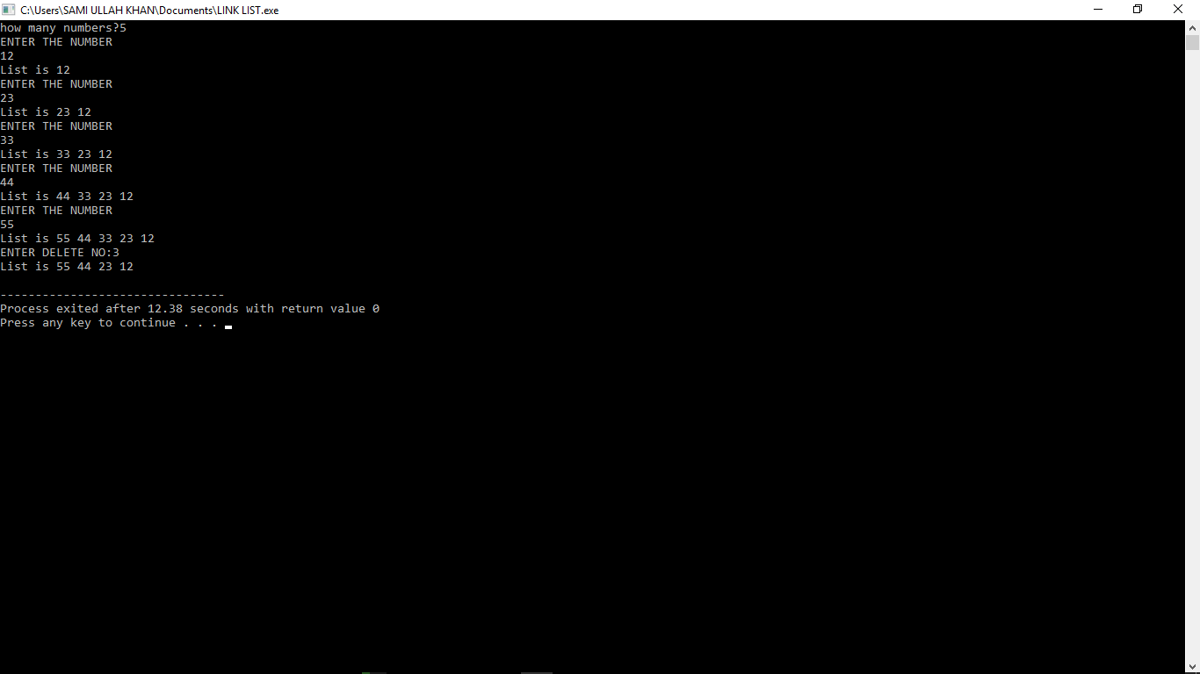

# 4 Conclusion

In this lab we learn about the application of link list and alo how it work and got the idea about the link list and perform them prectcaly on computer in c++ and also perform the deletion method in this lab on link list..